|  |  |
| --- | --- |
| **Inferential Statistics** | |
| As a data analyst working for ABC company, you are tasked with finding the average rent for all fully furnished 2 BHK flats using the data provided. | |
| a. | What is the 90% confidence interval for the monthly rent in rupees? |
| b. | What is the 99% confidence interval for the monthly rent in rupees? |
| c. | Your boss decides to fix the monthly rent at ₹46,500 and she asks you if this is close enough to the average. She asks you to decide based on a 95% confidence level.    Does the rent fixed by your boss (₹46,500) lie inside the 95% confidence interval for monthly rent? |
|  |  |

a)

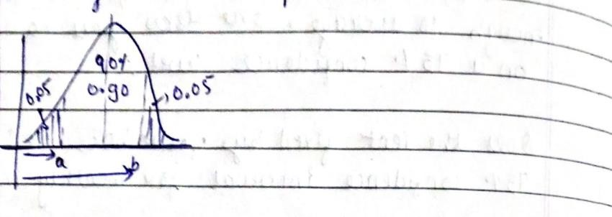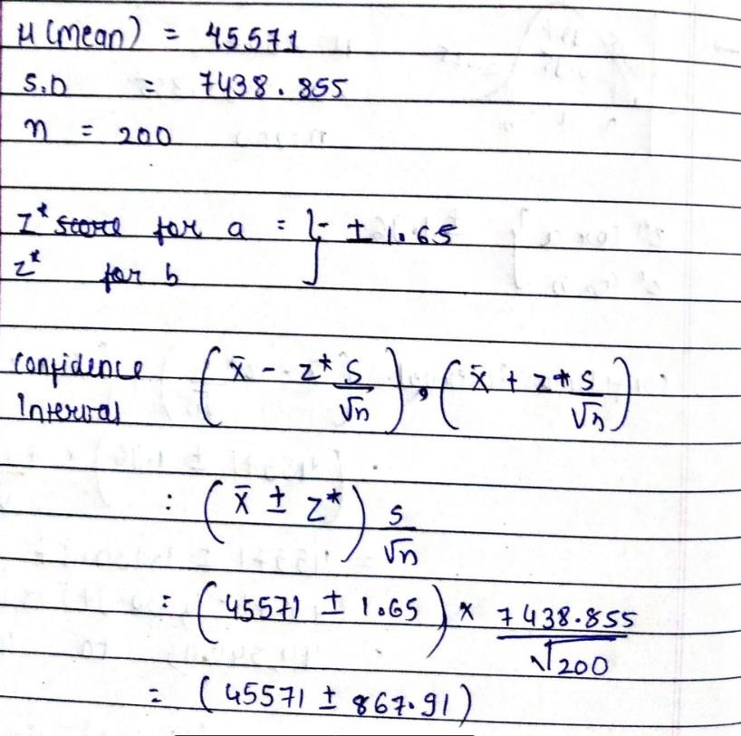

b)

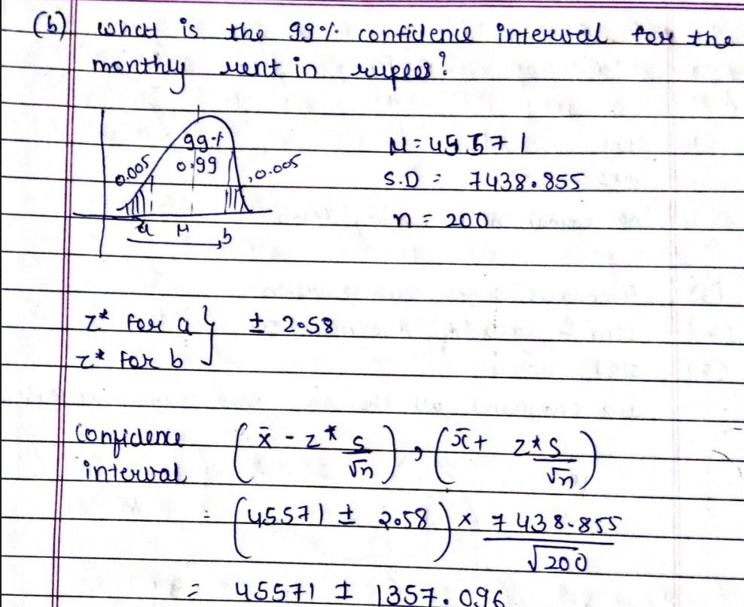

c)

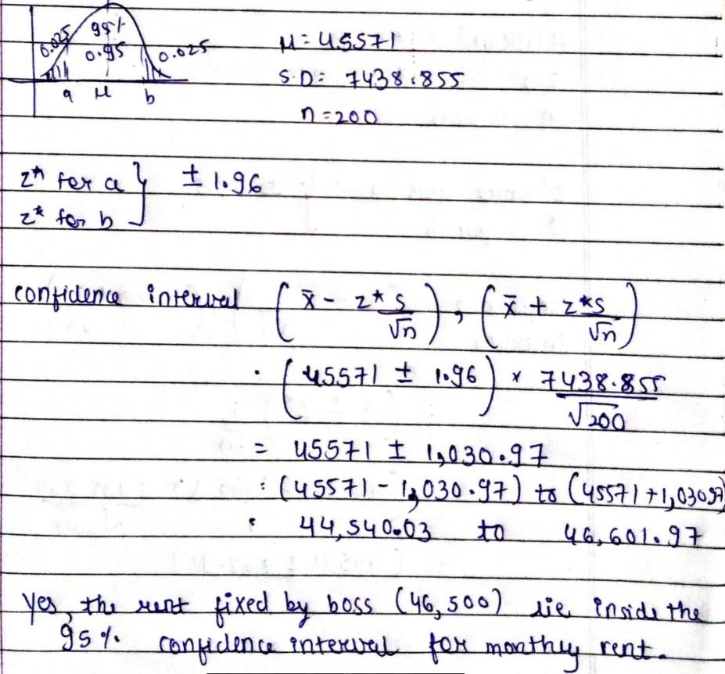

Hypothesis Testing

Formulate the null and alternative hypothesis for the following statements.

a. We want to test whether the mean GPA of students in American colleges is different from 2.0

(out of 4.0).

b. We want to test whether the mean height of eighth graders is 66 inches.

c. We want to test if college students take less than five years to graduate from college, on the

average.

d. We want to test if it takes fewer than 45 minutes to teach a lesson plan.

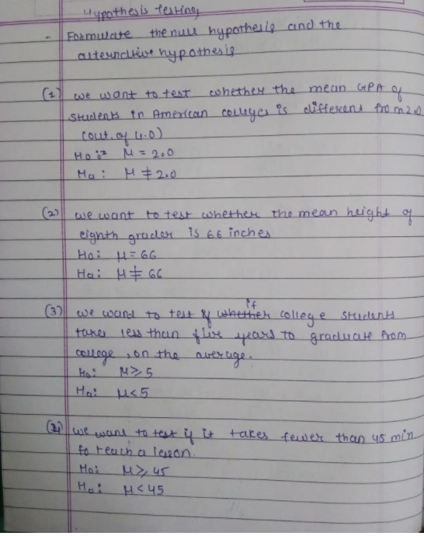

Test Hypothesis

a. A monthly income investment scheme exists that promises variable monthly returns. An investor will invest in it only if they are assured of an average $180 monthly income. The investor has a sample of 300 months’ returns which has a mean of $190 and a standard deviation of $75. Should they invest in this scheme?

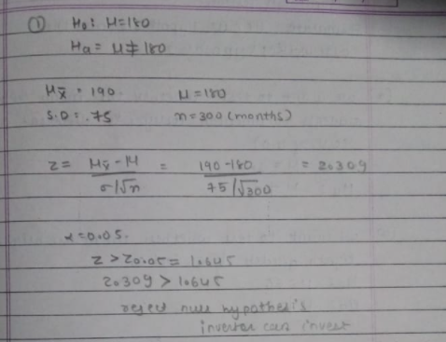

b. A new stockbroker (XYZ) claims that their brokerage fees are lower than that of your current stock broker's (ABC). Data available from an independent research firm indicates that the mean and std-dev of all ABC broker clients are $18 and $6, respectively. A sample of 100 clients of ABC is taken and brokerage charges are calculated with the new rates of XYZ broker. If the mean of the sample is $18.75 and std-dev is the same ($6), can any inference be made about the difference in the average brokerage bill between ABC and XYZ broker?



